Linux Administration Assignment 3 Day 6 LU:
Questions:

- Use ps to search for the “systemd” process by name.
Use command ps -e | grep systemd

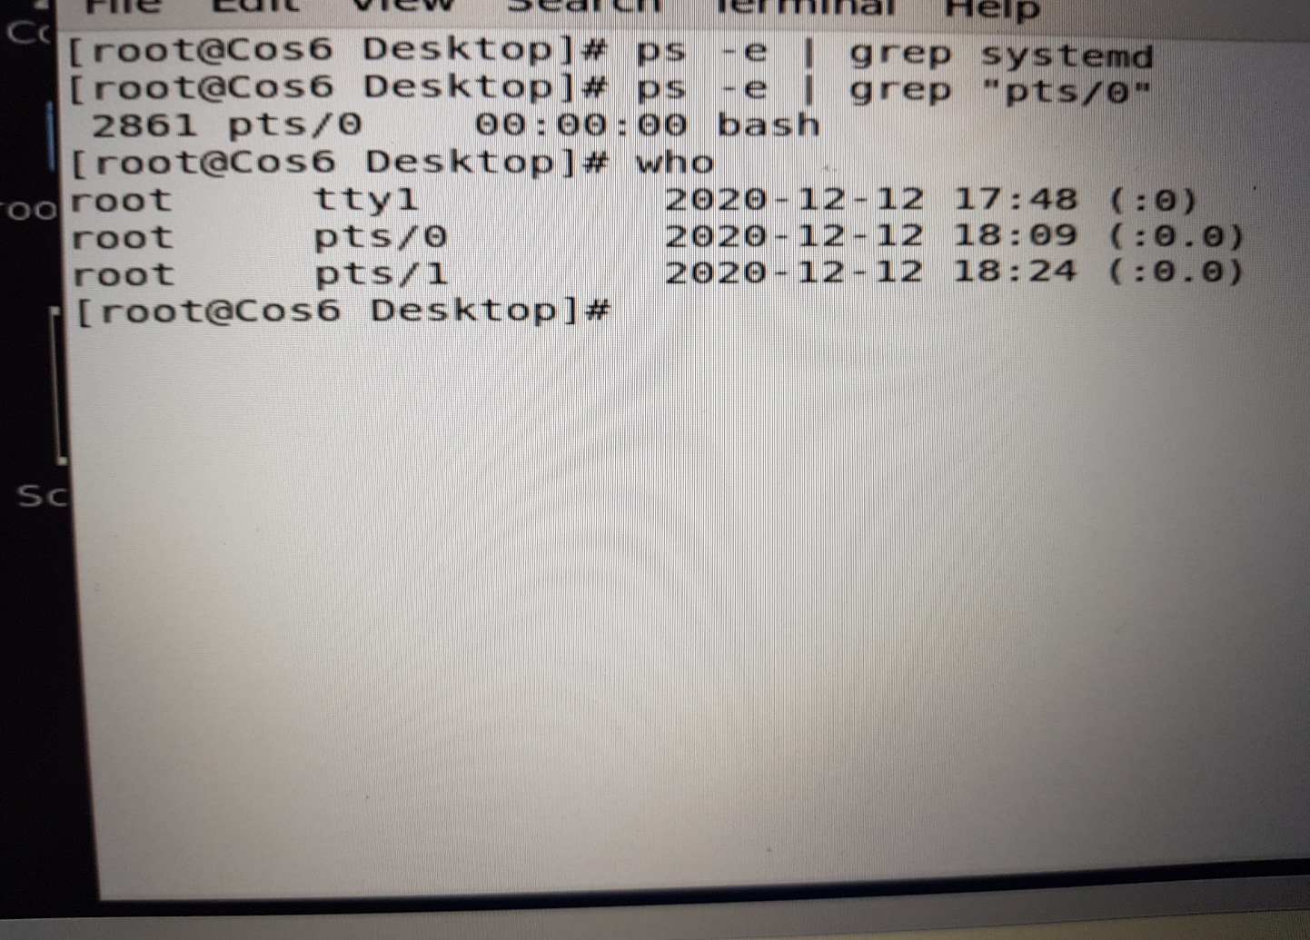
- Find out your terminal name. Using your terminal name, use ps to find all processes associated with your terminal.
Commands to use to find terminal name is ps -e | grep “pts/0”
For other process use “who”
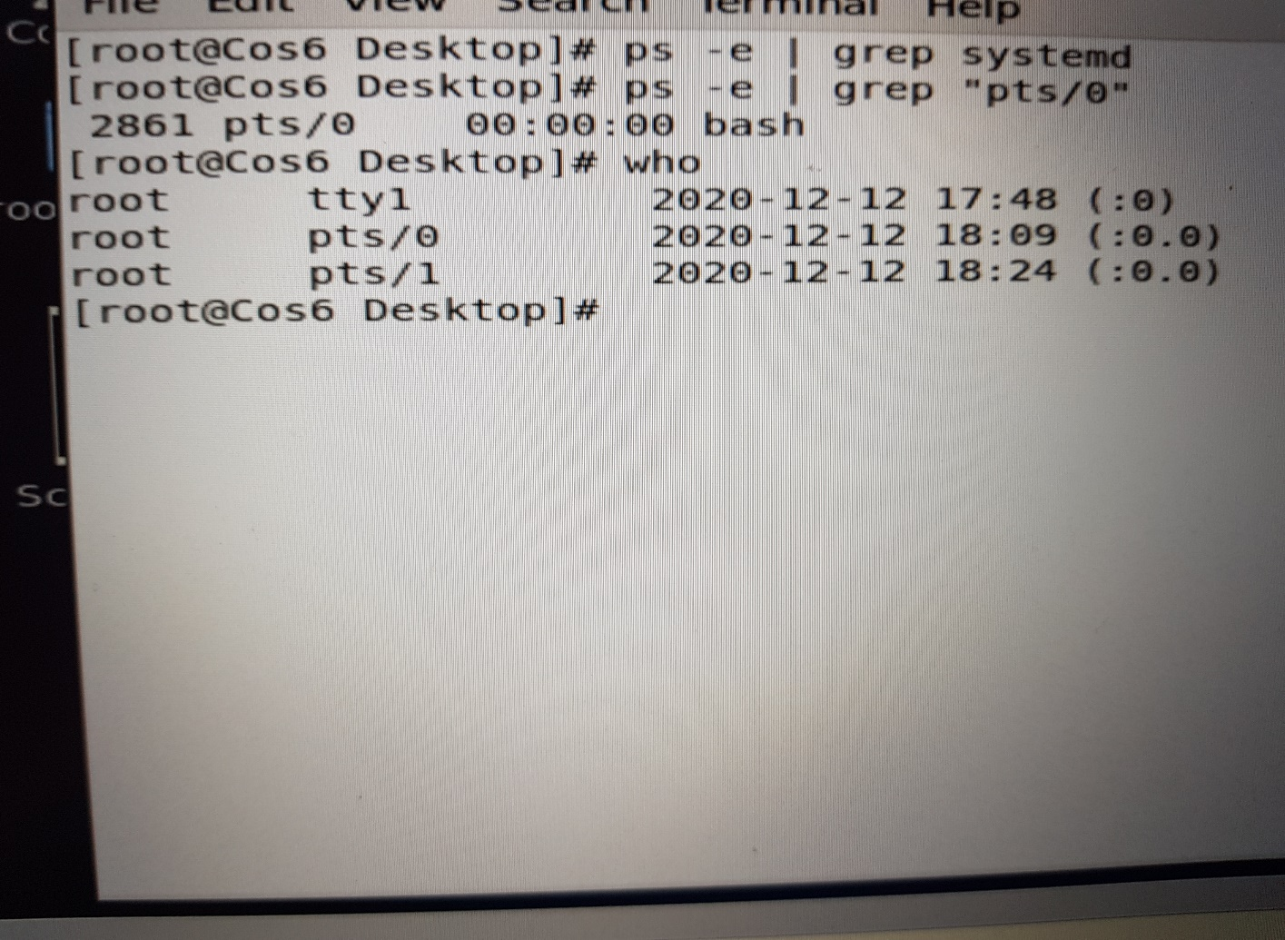

3. Check and note the process id of your shell (from the output of the above command).
Also, note the parent process id of your shell.
Commands to use are ps -e and the parent process id.2861
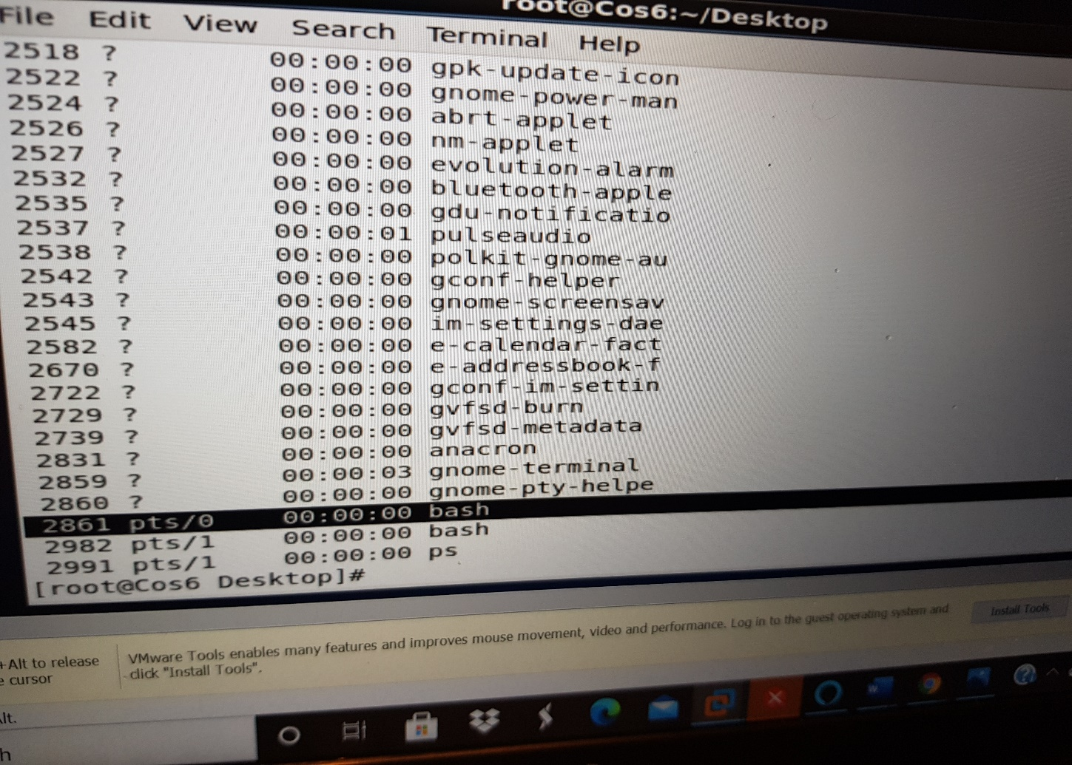
4.Start 3 instances of “sleep 123” as background processes.
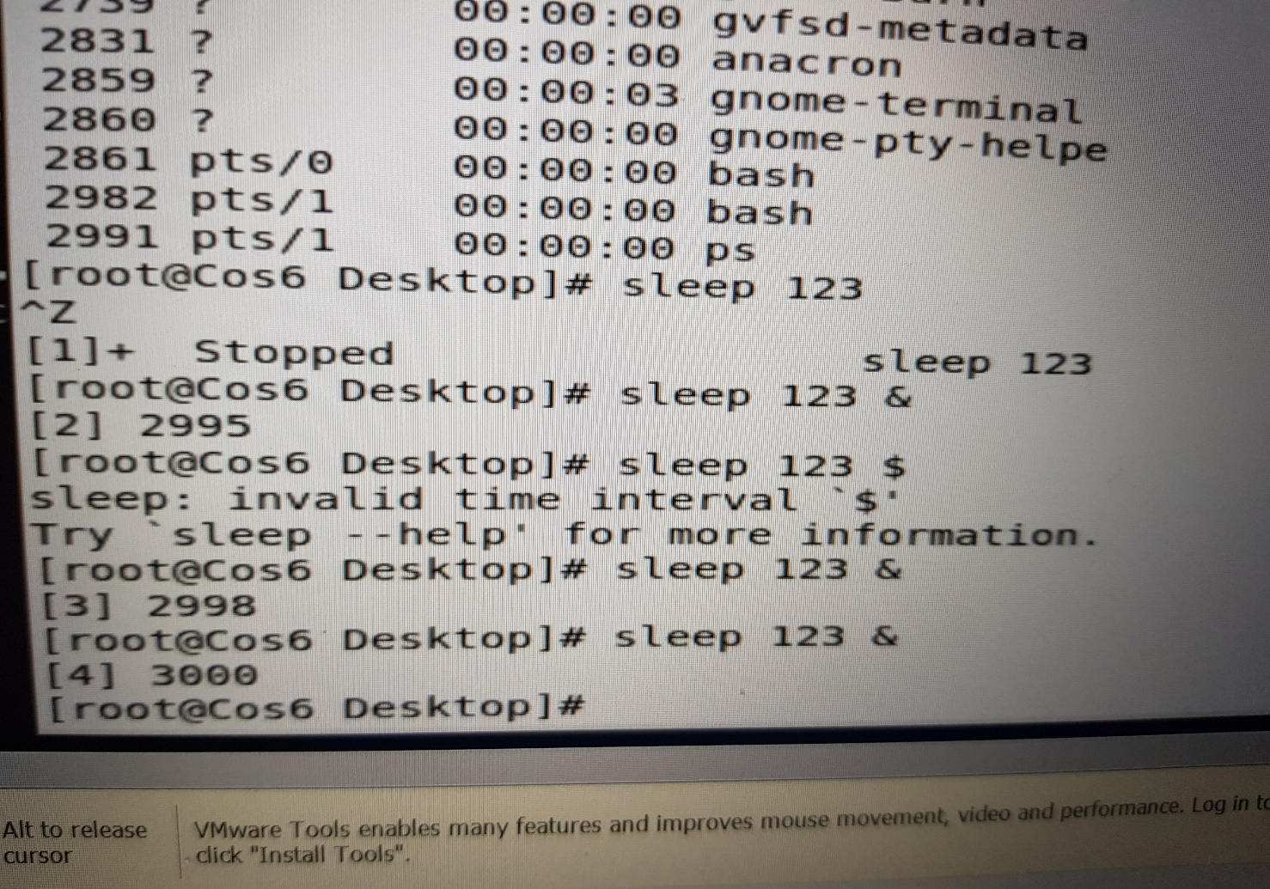

5. Check and note the process id’s of all sleep processes.
The process IDs are 2994 ,2998 and 3000
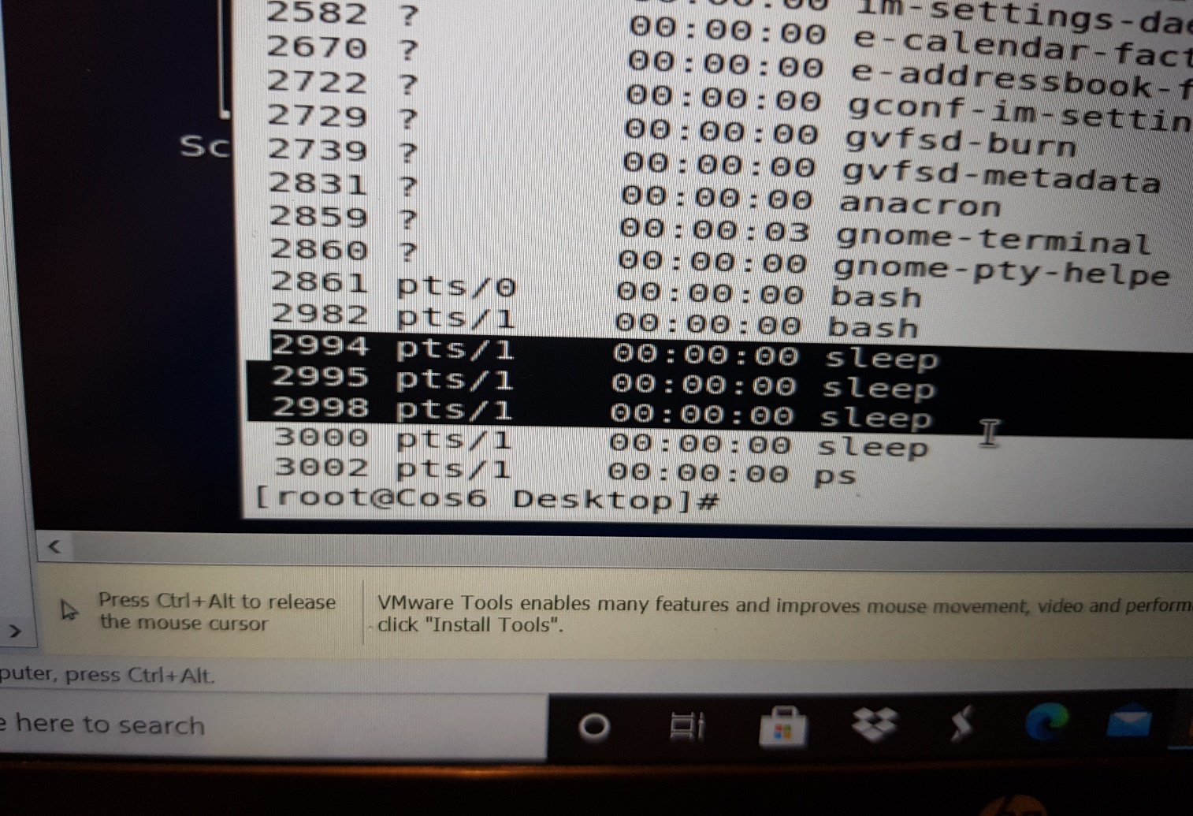

6. Display only those three sleep processes in top. Then quit top.
We use command top -b | grep sleep